Infinitive Phrase as an Object Complement

✅ What Is an Infinitive Phrase as an Object Complement?
# Source: AI Source: Provided by: [Data Path: Persons Table -> ID Column: 1, Name_En Column: Motasem Essam] -> From: [ChatGPT] on [8/4/2025]
An infinitive phrase can act as an object complement when it follows a direct object and explains what the object is expected to do, become, or experience as a result of the action. It typically includes "to" + base verb, sometimes with modifiers or objects.

🔸 Key Features:
# Source: AI Source: Provided by: [Data Path: Persons Table -> ID Column: 1, Name_En Column: Motasem Essam] -> From: [ChatGPT] on [8/4/2025]
- Follows a direct object
- Begins with "to" + verb (infinitive)
- Explains what the object does, should do, or is caused to do
- Common after verbs like:
advise, expect, cause, tell, want, force, encourage, order, allow

🔸 Examples of Infinitive Phrase Object Complements:
# Source: AI Source: Provided by: [Data Path: Persons Table -> ID Column: 1, Name_En Column: Motasem Essam] -> From: [ChatGPT] on [8/4/2025]
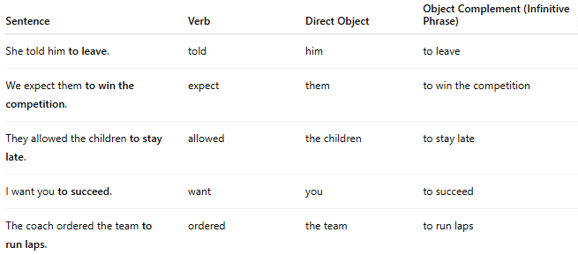
Sentence | Verb | Direct Object | Object Complement (Infinitive Phrase)
She told him to leave. | told | him | to leave
We expect them to win the competition. | expect | them | to win the competition
They allowed the children to stay late. | allowed | the children | to stay late
I want you to succeed. | want | you | to succeed
The coach ordered the team to run laps. | ordered | the team | to run laps

🔸 How to Identify:
# Source: AI Source: Provided by: [Data Path: Persons Table -> ID Column: 1, Name_En Column: Motasem Essam] -> From: [ChatGPT] on [8/4/2025]
Ask:
- What did she tell him? → To leave
- What do we expect them (to do)? → To win the competition
If the phrase begins with “to” + a verb and completes the idea of the object’s role or action, it functions as an infinitive phrase object complement.

